37B How to Trade

date: 2024-05-09

Every chart and every part of every chart is either in breakout, channel or in trading range.

market cycle
- Market is in never ending cycle and keeps recycling the same patterns over and over again

- It is important to learn to recognize what the chart is currently doing since you have to trade differently depending on what part of market cycle the market is currently in

- Believing there are really important times to enter and those are the only time you should enter is a fallacy

- If you learn how to read the charts, you can structure trades any bar at any time - as long as trader’s equation is positive, that is an acceptable trade

- It’s often helpful to try to structure binary decision:
- Bull trend or a Bear trend?
- is it leg in trend or in TR?
- if it is a bull trend then is it a bull breakout or channel?

And you trade accordingly:
- if its a bull breakout, buy at least small position and you buy for any reason

- when a bull channel is reasonably tight, better only to buy
(whenever market is either in breakout or a channel, swing at least part of your trade)

- only sell in bull channel if channel is broad enough and there is room for scalp and market is in stair pattern

- often, trading range begins when market is still in channel - BLSH and scalp
- when range is too tight, do not trade at all

Same when market is falling down
- Bear trend or bear leg in TR?
- Bear BO or bear channel?

- Only take the trade if you can manage it correctly and important part of managing correctly is using appropriate stop

- If its not clearly in TR, then better to only trade in direction of the trend

- In broad bull channel, pullbacks will be around midpoint of last leg, so buy in middle or bottom third of last leg up

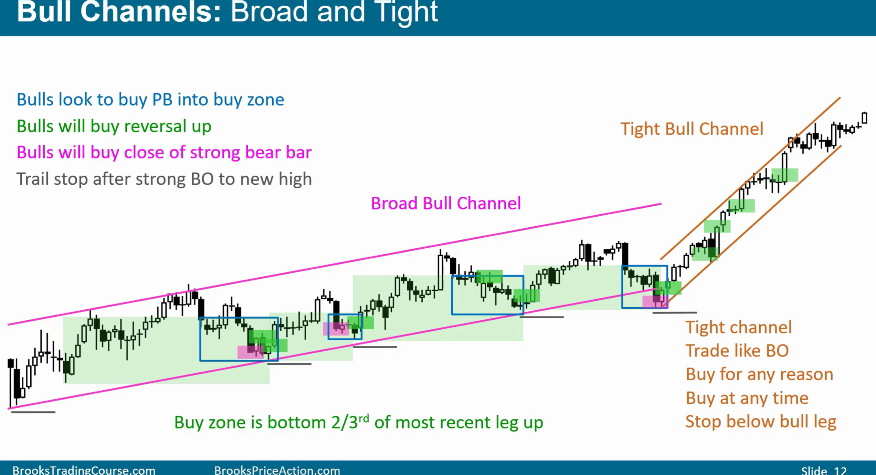

Similarly, in broad bear channel, middle or top third of last leg down is a sell zone. Trail stop after strong BO to new low.

Because its bear trend, its easier to make money selling so traders should be concentrating on taking sell signals (for scalps and swings)
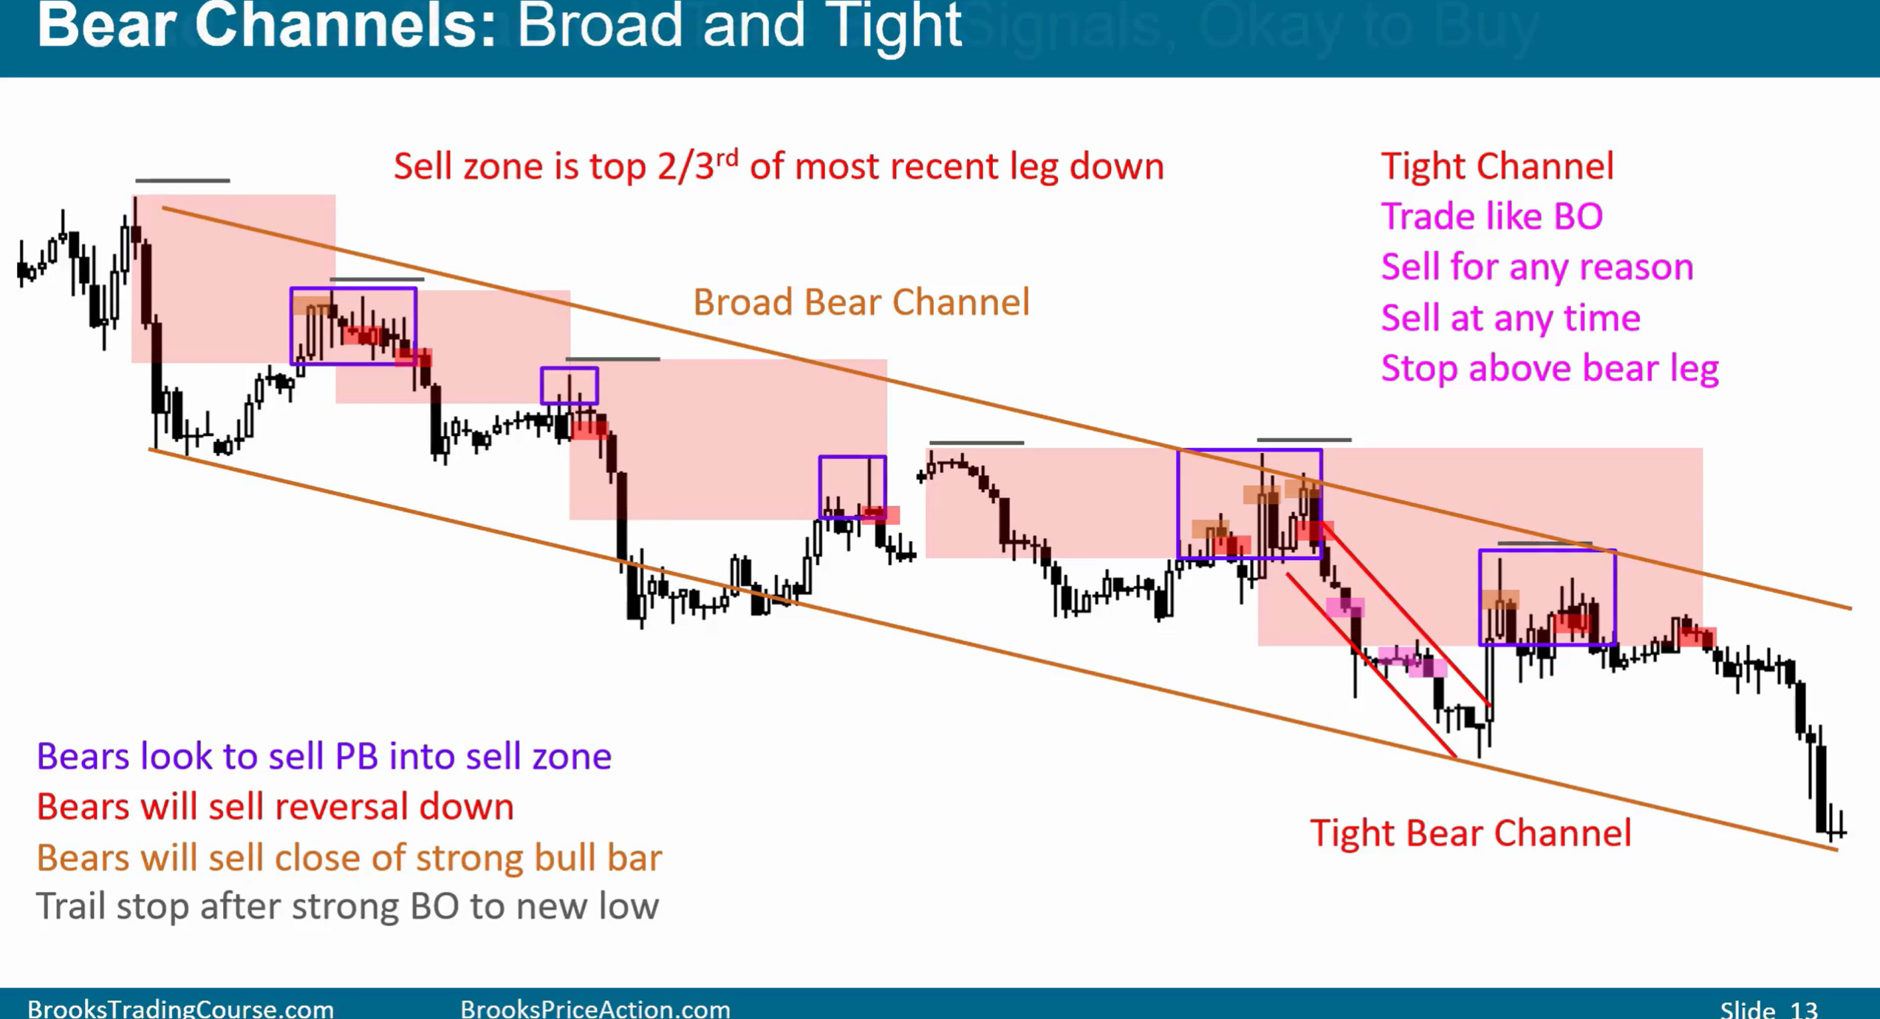
Experts can buy reversals up from new lows for scalps, especially 2nd leg, and cover somewhere in the sell zone (but only experienced traders should do that)

Trading Ranges:
- As trend develop, it tends to weaken and eventually becomes a trading range
- When market enters trading range, traders should look to buy low, sell high and scalp (even if market could be forming broad channels)

- If unclear, wait for second signal, i.e. if leg up is strong take the second sell

- In trading range, buy lower third, sell upper third (60% probability of moving scalp size down before going that much above)
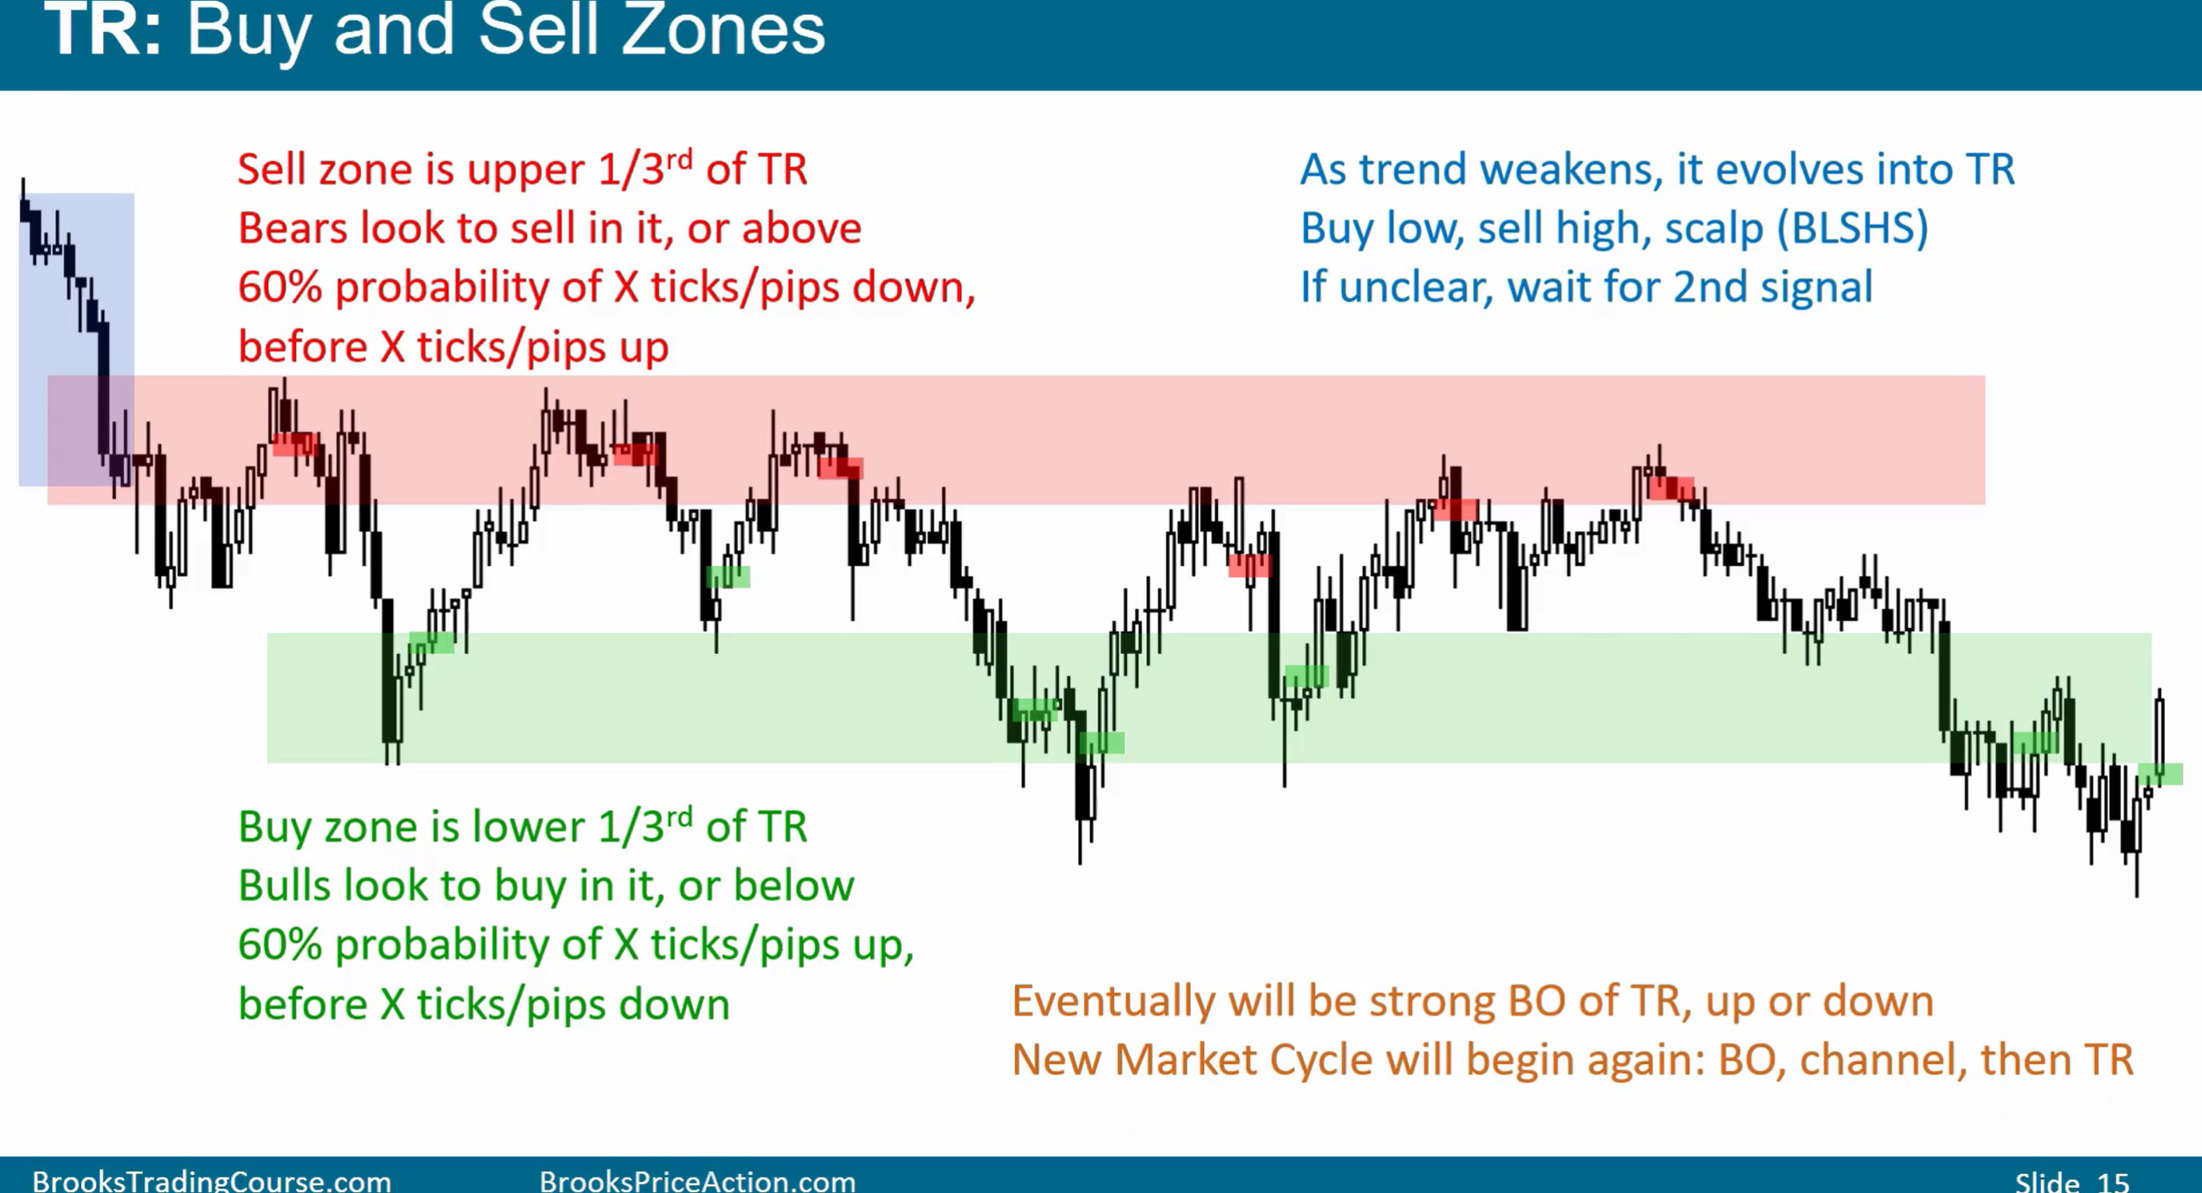
- Market cycle means market alternates between trends and trading ranges
- Trade it like TR as long as it is in TR and once it clearly converts into breakout, then treat it like a new cycle

What happens if you missed the ‘best signal’?
- There is no ‘best’ or perfect signal, but there are many good signals and you can enter on almost any bar

- It does not matter where in the market cycle you began trading (every part of the cycle offers profitable setups)
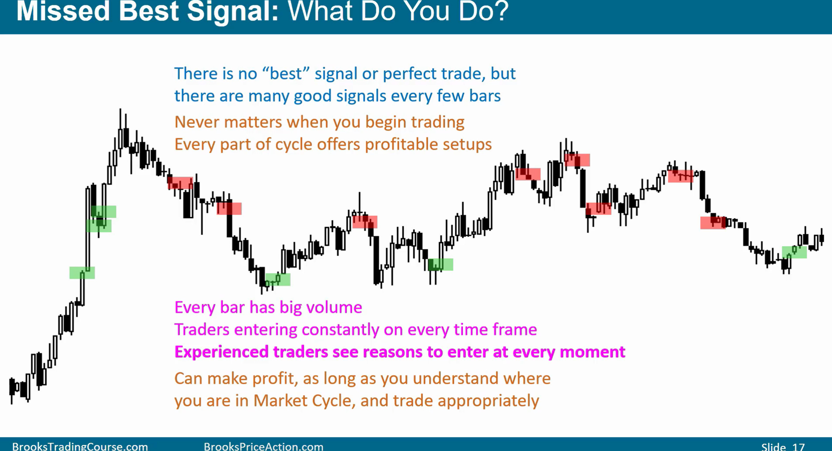
Trader’s Equation and 40-60 rule

- In any given chart, only about 5~10% of the bars are in strong breakout, (when you should only trade with the breakout)

- 90% of the bars are either in trading range or channel (40-60 rule) – both bulls and bears can make money with opposite trades if they manage it correctly

- high probability trade means bad risk reward ratio and good ratio means low probability
- both are acceptable if you can manage them correctly

- low probability trade means you need at least 2x actual risk for positive trader’s equation
- high probability trade needs at lest x1 actual risk for positive trader’s equation

All trends constantly try to reverse but more likely they are minor. It is hard to hold short, so learn to rely on your stop
- Don’t scalp when trend is strong and be patient
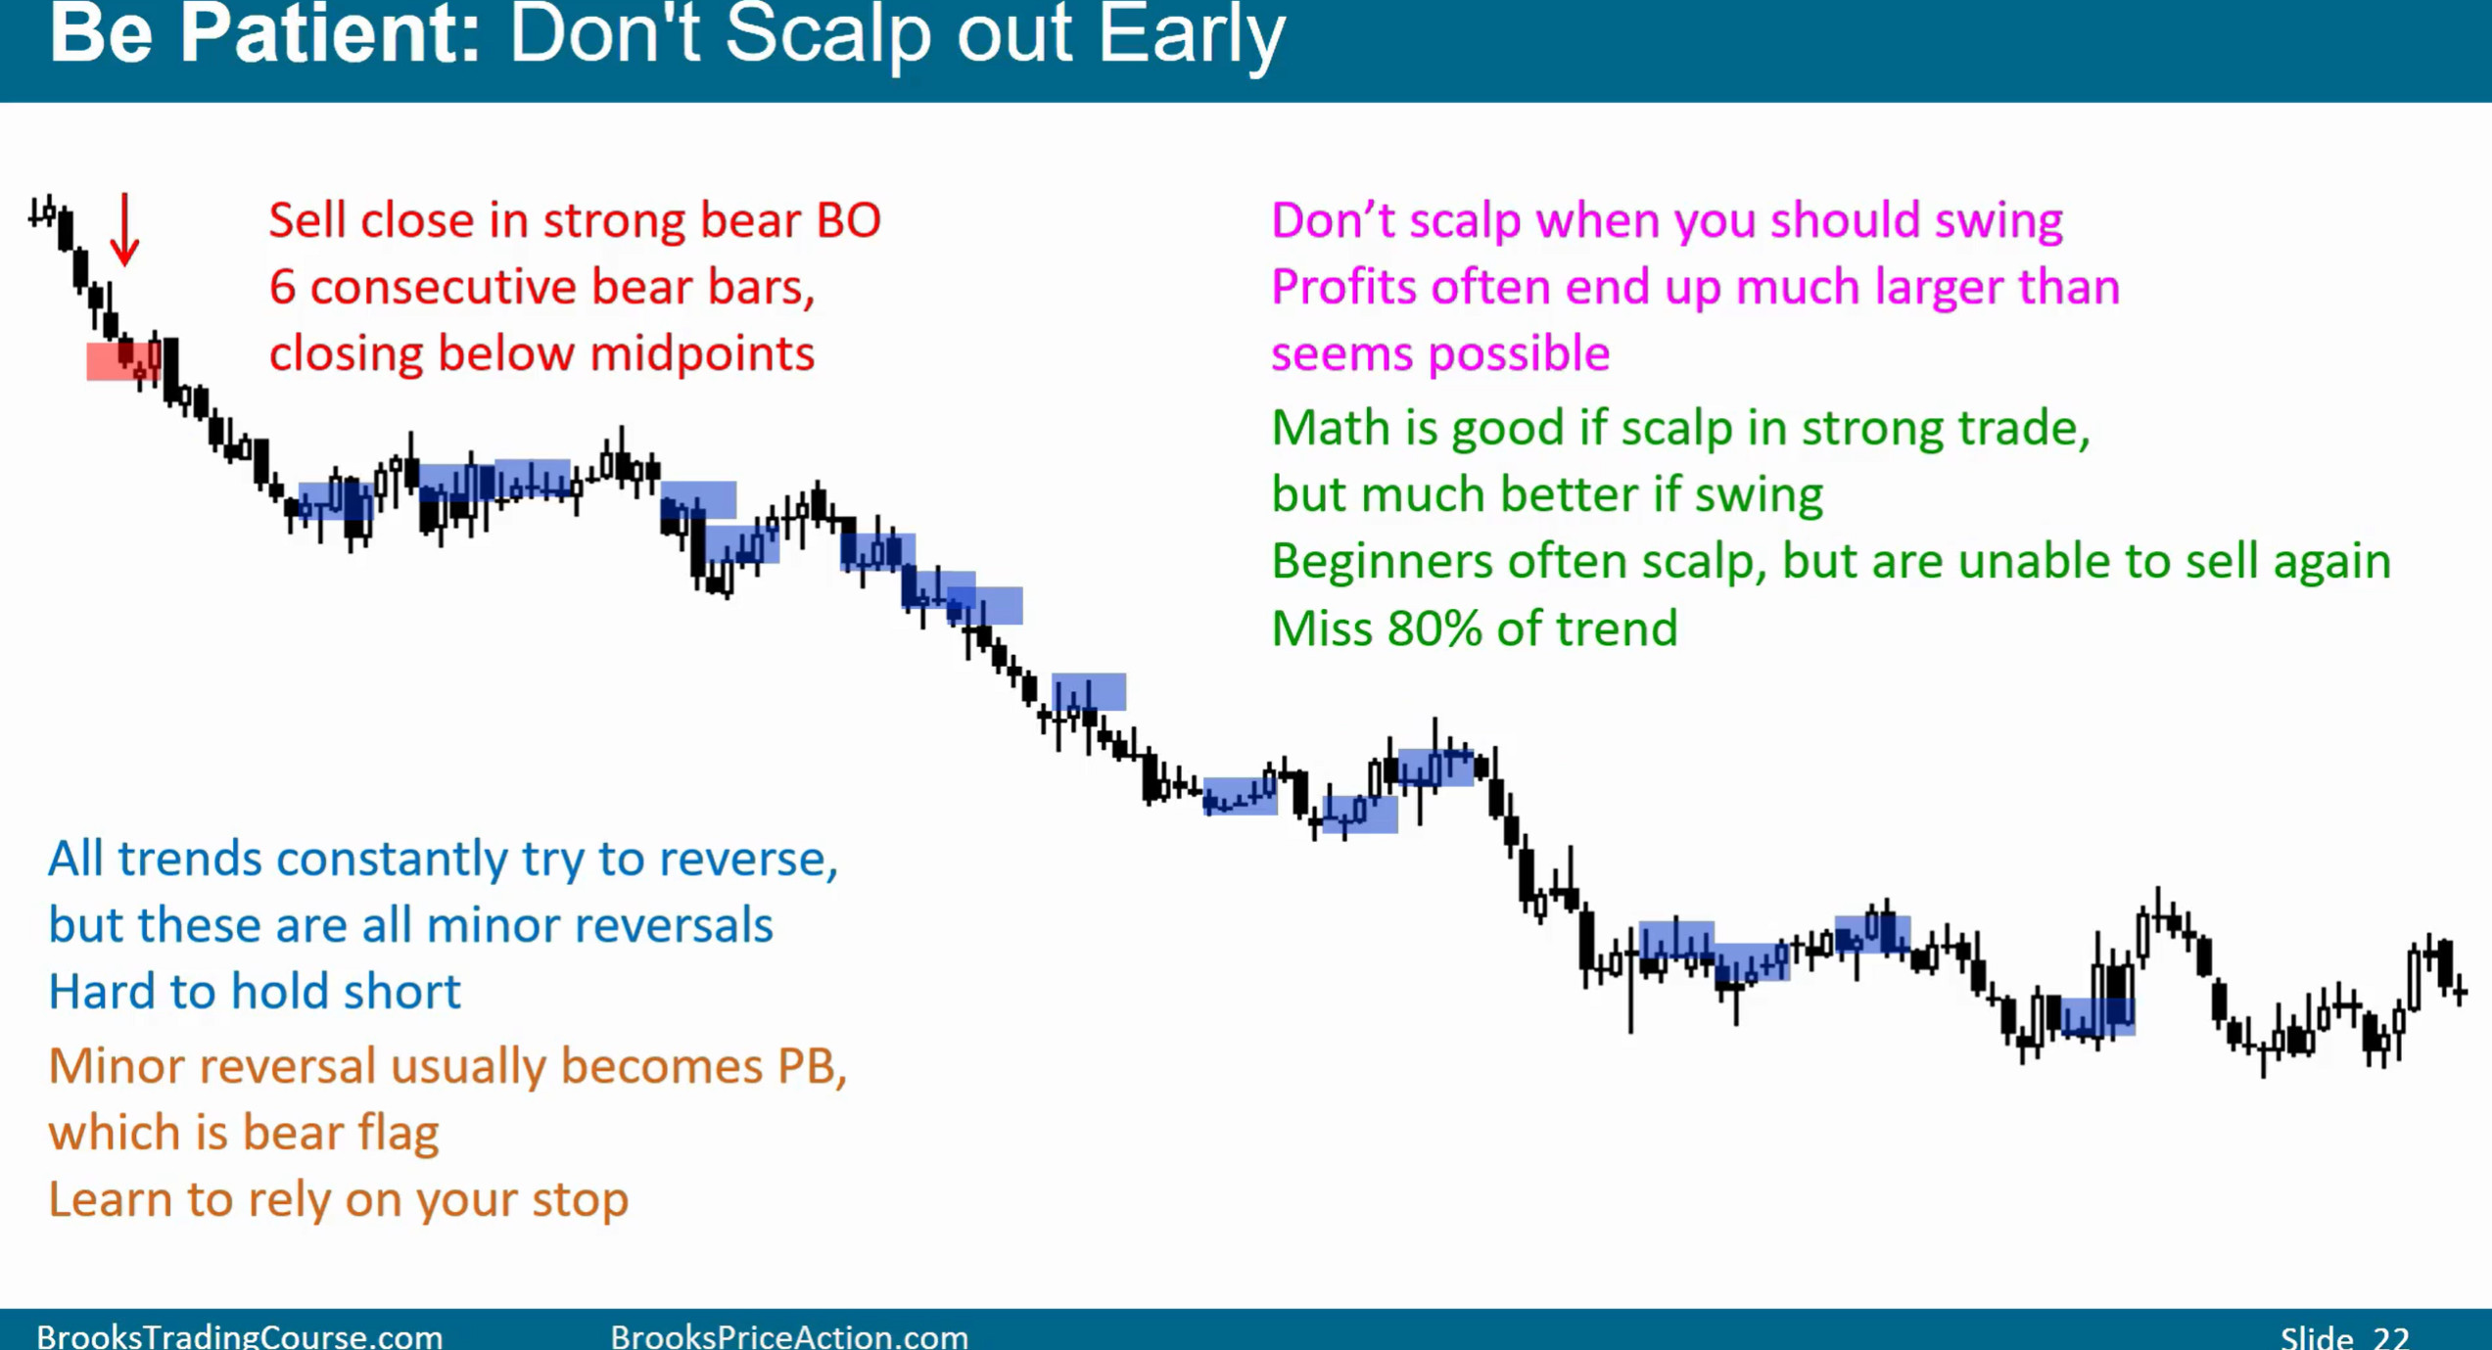
Default target

- Most traders are note very good with determining probabilities, 90% of the chart the probabilities are around 40~60%

- There are many ways to take profits but when its not clear, a good default plan is 2x initial risk
